 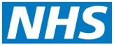

**Primary Care Networks**

**in Norfolk and Waveney**

Primary care networks (PCNs) are new groups of GP practices working closely together with other community, mental health and social care staff to improve services for local people.

PCNs will be responsible for delivering joined-up health and care services through multi-professional teams to patients in the community.

Patients will continue to remain registered with their own GP practice, but working as part of a network will enable GP practices in Norfolk and Waveney to share expertise and resources.

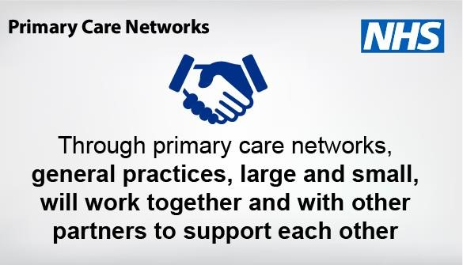

* Primary care networks have the potential to benefit patients by offering improved access to an extended range of services, recruitment of additional health staff, and by helping to integrate primary care with wider health and community services.

* New staff may include clinical pharmacists, physiotherapists, paramedics, physician associates and social prescribing link workers. They will improve access for patients and will help ensure that patients can see the professional that is most appropriate for their needs.

# We have created 17 primary care networks in Norfolk and Waveney

PCNs were introduced across the country in July 2019 and are still evolving. Each PCN typically has a patient population of about 30,000 to 50,000 patients, so this might mean four or five practices.

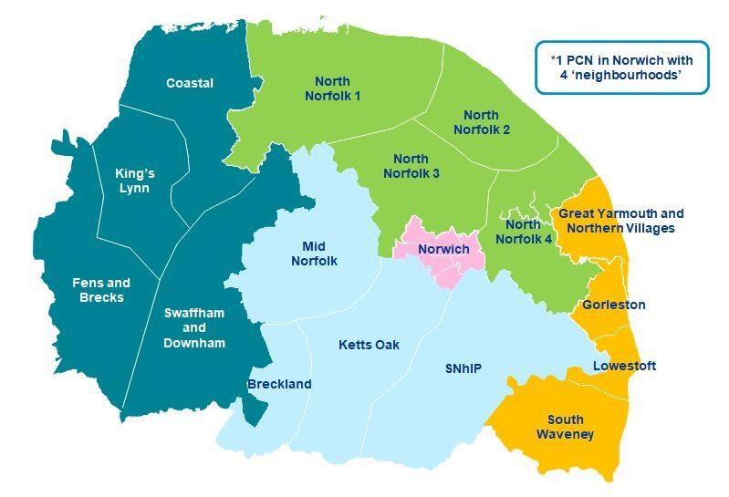

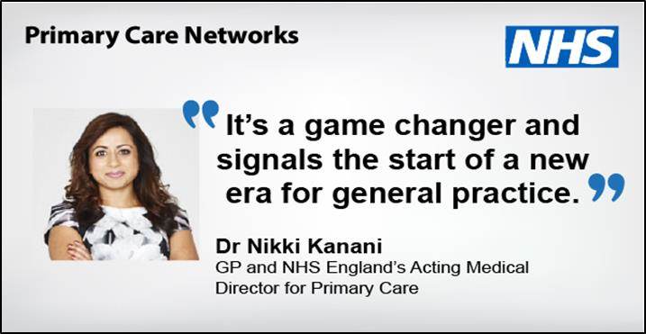

# What PCNs are achieving in Norfolk and Waveney so far

|  |
| --- |
| **Case study**  In Great Yarmouth and Waveney a new adult community services contract has an emphasis on integrating services with general practice through PCNs |

## Community services

The four main organisations providing adult community services (Norfolk and Suffolk County Councils, Norfolk Community Health and Care and East Coast Community Healthcare) have already clustered their operational teams around our PCNs.

## Mental health

A new model of care is being developed with Norfolk and Suffolk NHS Foundation Trust (NSFT), aligned with PCNs. This is in line with our Norfolk and Waveney [mental health strategy](https://norfolkandwaveneypartnership.org.uk/our-work/better_care_for_people/mental-health.html) published earlier this year. Team members are likely to include a GP champion, supported by a mental health nurse, a named psychiatrist, peer support, dementia practitioner, trauma therapist, wellbeing practitioner including long term conditions, carer champion and a social navigator.

## Care homes

We have developed an Enhanced Health in Care Homes (EHCH) programme which has strengthened care quality in a number of our care homes and builds on locally commissioned services from general practice. We will fully develop the programme so that it is in place in each PCN and introduced to all care homes by 2021.

|  |  |  |  |
| --- | --- | --- | --- |
| |  | | --- | | **Case Study**  In North Norfolk an Enhanced Care Home Team is supporting care homes and general practices. The service is reducing admissions to hospital and reducing the number of GP visits needed by offering a more tailored and organised service for care homes. | | |  | | --- | | **Case study**  South Norfolk PCNs have worked collaboratively with local care providers and have developed a visiting nurse model to support patients and improve clinical care. | |

## End of Life

A newly commissioned specialist palliative care service in Great Yarmouth and

Waveney, integrating care delivery between East Coast Community Healthcare (ECCH), St Elizabeth Hospice and James Paget University Hospital provides specialist palliative care bed and day service provision, working closely with PCNs. This is supported by a 24/7 advice line for patients and their families as well as health and care professionals

## Helping people remain safe and well in their homes

A range of initiatives are underway across Norfolk and Waveney to support patients to stay well in their homes and prevent avoidable admissions to hospital. PCNs are also developing their approaches to population health management - this is a way of identifying groups of people who are at risk of ill health and predicting which individuals are most likely to benefit from further help.

|  |  |  |
| --- | --- | --- |
| **Case study**  In Norwich and Lowestoft a shared home visiting service is being piloted to both reduce emergency activity and to support the resilience of general practice. |  | **Case study**  In West Norfolk work is underway to ensure that emerging PCN transformation projects reflect the needs of the local community. A frailty project is underway in the Coastal PCN. |

**Where can I find out more information?**

Further information is included in the NHS England website at [www.england.nhs.uk/pcn.](http://www.england.nhs.uk/pcn) In addition, a series of FAQs have been published and are available at [https://www.england.nhs.uk/primary-care/primary-care-networks/pcnfaqs](https://www.england.nhs.uk/primary-care/primary-care-networks/pcn-faqs)

Appendix: **Which PCN is my Practice in?**

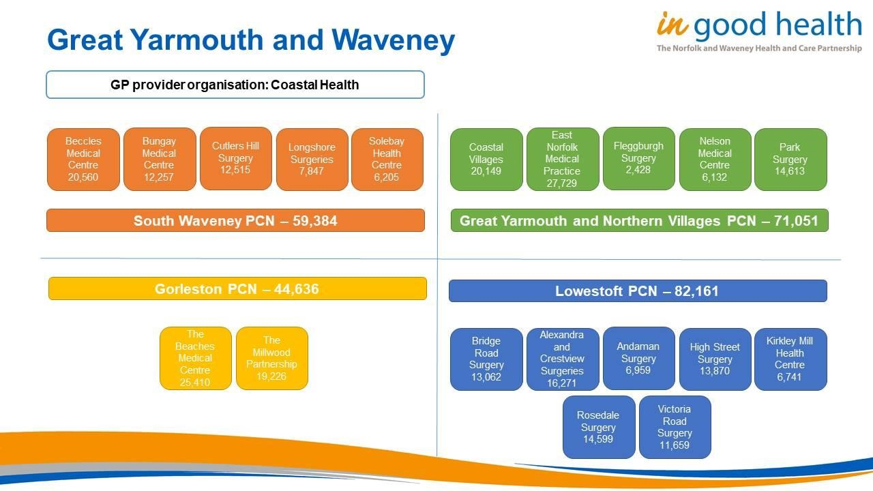

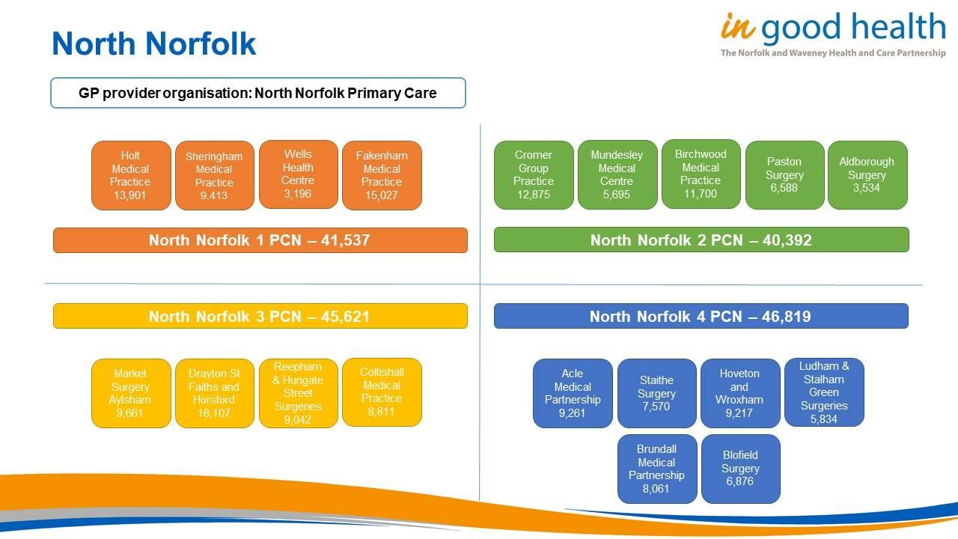

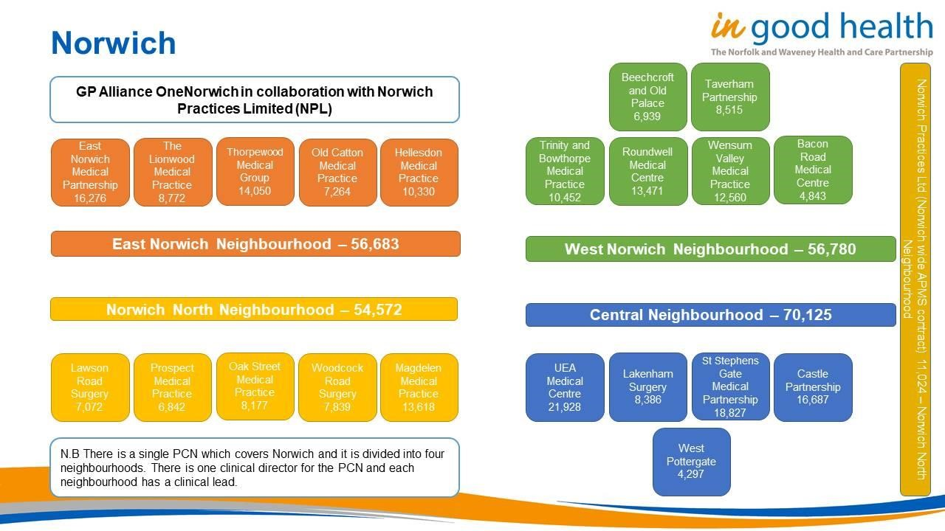

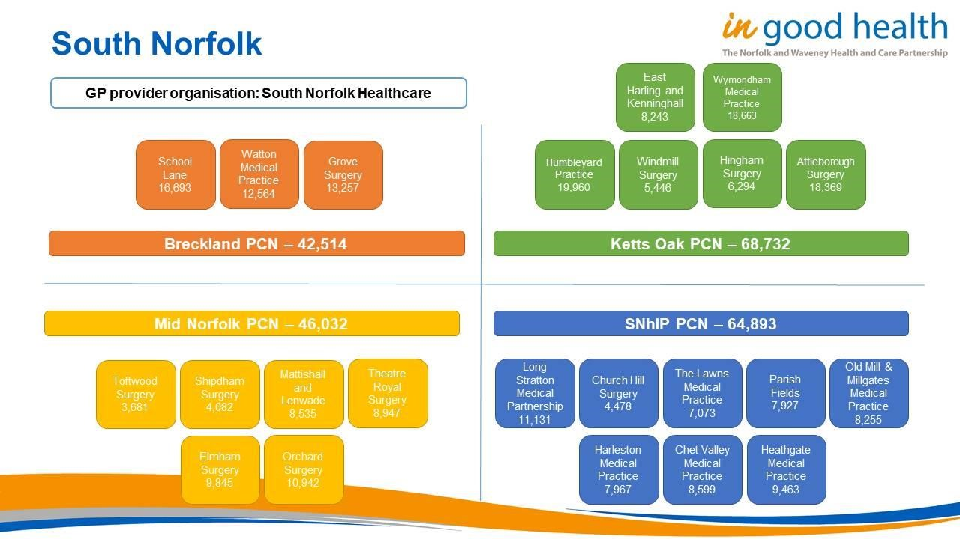

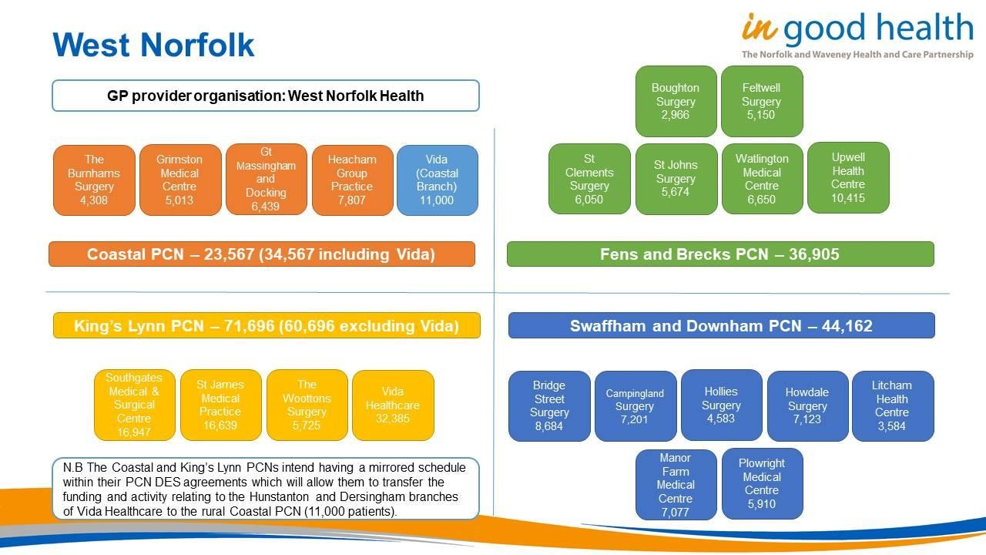

|  |  |  |
| --- | --- | --- |
| **Practice** | **Primary Care Network** | **Locality** |
| Acle Medical Partnership | North Norfolk 4 PCN | North Norfolk |
| Aldborough Surgery | North Norfolk 2 PCN | North Norfolk |
| Alexandra and Crestview Surgeries | Lowestoft PCN | Great Yarmouth and Waveney |
| Andaman Surgery | Lowestoft PCN | Great Yarmouth and Waveney |
| Attleborough Surgery | Ketts Oak PCN | South Norfolk |
| Bacon Road Medical Centre | West Norwich Neighbourhood | Norwich |
| Beccles Medical Centre | South Waveney PCN | Great Yarmouth and Waveney |
| Beechcroft and Old Palace | West Norwich Neighbourhood | Norwich |
| Birchwood Medical Practice | North Norfolk 2 PCN | North Norfolk |
| Blofield Surgery | North Norfolk 4 PCN | North Norfolk |
| Boughton Surgery | Fens and Brecks PCN | West Norfolk |
| Bridge Road Surgery | Lowestoft PCN | Great Yarmouth and Waveney |
| Bridge Street Surgery | Swaffham and Downham PCN | West Norfolk |
| Brundall Medical Partnership | North Norfolk 4 PCN | North Norfolk |
| Bungay Medical Centre | South Waveney PCN | Great Yarmouth and Waveney |
| Campingland Surgery | Swaffham and Downham PCN | West Norfolk |
| Castle Partnership | Central neighbourhood | Norwich |
| Chet Valley Medical Practice | SNhIP PCN | South Norfolk |
| Church Hill Surgery | SNhIP PCN | South Norfolk |
| Coastal Villages | Great Yarmouth and Northern Villages PCN | Great Yarmouth and Waveney |
| Coltishall Medical Practice | North Norfolk 3 PCN | North Norfolk |
| Cromer Group Practice | North Norfolk 4 PCN | North Norfolk |
| Cutlers Hill Surgery | South Waveney PCN | Great Yarmouth and Waveney |
| Drayton St Faiths and Horsford | North Norfolk 3 PCN | North Norfolk |
| East Harling and Kenninghall Medical Practice | Ketts Oak PCN | South Norfolk |
| East Norfolk Medical Practice | Great Yarmouth and Northern Villages PCN | Great Yarmouth and Waveney |
| East Norwich Medical Partnership | East Norwich Neighbourhood | Norwich |
| Elmham Surgery | Mid Norfolk PCN | South Norfolk |
| Fakenham Medical Practice | North Norfolk 1 PCN | North Norfolk |
| Feltwell Surgery | Fens and Brecks PCN | West Norfolk |
| Fleggburgh Surgery | Great Yarmouth and Northern Villages PCN | Great Yarmouth and Waveney |
| Great Massingham and Docking | Coastal PCN | West Norfolk |
| Grimston Medical Centre | Coastal PCN | West Norfolk |
| Grove Surgery | Breckland PCN | South Norfolk |
| Harleston Medical Practice | SNhiP PCN | South Norfolk |
| Heacham Group Practice | Coastal PCN | West Norfolk |
| Heathgate Medical Practice | SNhIP PCN | South Norfolk |
| Hellesdon Medical Practice | East Norwich Neighbourhood | Norwich |
| High Street Surgery | Lowestoft PCN | Great Yarmouth and Waveney |
| Hingham Surgery | Ketts Oak PCN | South Norfolk |
| Hollies Surgery | Swaffham and Downham PCN | West Norfolk |
| Holt Medical Practice | North Norfolk 1 PCN | North Norfolk |
| Howdale Surgery | Swaffham and Downham PCN | West Norfolk |
| Hoveton and Wroxham Medical Centre | North Norfolk 4 PCN | North Norfolk |
| Humbleyard Practice | Ketts Oak PCN | South Norfolk |
| Kirkley Mill Health Centre | Lowestoft PCN | Great Yarmouth and Waveney |
| Lakenham Surgery | Central Neighbourhood | Norwich |
| Lawson Road Surgery | Norwich North Neighbourhood | Norwich |
| Litcham Health Centre | Swaffham and Downham PCN | West Norfolk |

|  |  |  |  |  |
| --- | --- | --- | --- | --- |
| Longshore Surgeries |  | South Waveney PCN | Great Yarmouth and Waveney | |
| Long Stratton Medical Partnership |  | SNhIP PCN | South Norfolk | |
| Ludham and Stalham Green Surgeries |  | North Norfolk 2 PCN | North Norfolk | |
| Magdalen Medical Practice |  | Norwich North Neighbourhood | Norwich | |
| Manor Farm Medical Centre |  | Swaffham and Downham PCN | West Norfolk | |
| Market Surgery Aylsham |  | North Norfolk 3 PCN | North Norfolk | |
| Mattishall and Lenwade Surgeries |  | Mid Norfolk PCN | South Norfolk | |
| Mundesley Medical Centre |  | North Norfolk 2 PCN | North Norfolk | |
| Nelson Medical Centre |  | Great Yarmouth and Northern Villages PCN | Great Yarmouth and Waveney | |
| Norwich Practices’ Health Centre |  | Norwich North Neighbourhood | Norwich | |
| Oak Street Medical Practice |  | Norwich North Neighbourhood | Norwich | |
| Old Catton Medical Practice |  | East Norwich Neighbourhood | Norwich | |
| Old Mill and Millgates Medical Practice |  | SNhIP PCN | South Norfolk | |
| Orchard Surgery |  | Mid Norfolk PCN | South Norfolk | |
| Parish Fields Practice |  | SNhIP PCN | South Norfolk | |
| Park Surgery |  | Great Yarmouth and Northern Villages PCN | Great Yarmouth and Waveney | |
| Paston Surgery |  | North Norfolk 2 PCN | North Norfolk | |
| Plowright Medical Centre |  | Swaffham and Downham PCN | West Norfolk | |
| Prospect Medical Practice |  | Norwich North Neighbourhood | Norwich | |
| Reepham and Hungate Street Surgeries |  | North Norfolk 3 PCN | North Norfolk | |
| Rosedale Surgery |  | Lowestoft PCN | Great Yarmouth and Waveney | |
| Roundwell Medical Centre |  | West Norwich Neighbourhood | Norwich | |
| St Clements Surgery |  | Fens and Brecks PCN | West Norfolk | |
| St James Medical Practice |  | King’s Lynn PCN | West Norfolk | |
| St Johns Surgery |  | Fens and Brecks PCN | West Norfolk | |
| St Stephens Gate Medical Partnership |  | Central Neighbourhood | Norwich | |
| School Lane Surgery |  | Breckland PCN | South Norfolk | |
| Sheringham Medical Practice |  | North Norfolk 1 PCN | North Norfolk | |
| Shipdham Surgery |  | Mid Norfolk PCN | South Norfolk | |
| Solebay Health Centre |  | South Waveney PCN | Great Yarmouth and Waveney | |
| Southgates Medical and Surgical Centre |  | King’s Lynn PCN | West Norfolk | |
| Staithe Surgery |  | North Norfolk 4 PCN | North Norfolk | |
| Taverham Partnership |  | West Norwich Neighbourhood | Norwich | |
| Theatre Royal Surgery |  | Mid Norfolk PCN | South Norfolk | |
| The Beaches Medical Centre |  | Gorleston PCN | Great Yarmouth and Waveney | |
| The Burnhams Surgery |  | Coastal PCN | West Norfolk | |
| The Lawns Medical Practice |  | SNhIP PCN | South Norfolk | |
| The Lionwood Medical Practice |  | East Norwich Neighbourhood | Norwich | |
| The Millwood Partnership |  | Gorleston PCN | Great Yarmouth and Waveney | |
| The Woottons Surgery |  | King’s Lynn PCN | West Norfolk | |
| Thorpewood Medical Group |  | East Norwich Neighbourhood | Norwich | |
| Toftwood Surgery |  | Mid Norfolk PCN | South Norfolk | |
| Trinity and Bowthorpe Medical Practice |  | West Norfolk Neighbourhood | Norwich | |
| UEA Medical Centre |  | Central Neighbourhood | Norwich | |
| Upwell Health Centre |  | Fens and Brecks PCN | West Norfolk | |
| Victoria Road Surgery |  | Lowestoft PCN | Great Yarmouth and Waveney | |
| Vida (coastal branch) | | Coastal PCN | West Norfolk |
| Vida Healthcare | | King’s Lynn PCN | West Norfolk |
| Watton Medical Practice | | Breckland PCN | South Norfolk |
| Wells Health Centre | | North Norfolk 1 PCN | North Norfolk |
| Wensum Valley Medical Practice | | West Norwich Neighbourhood | Norwich |
| West Pottergate Medical Practice | | Central Neighbourhood | Norwich |
| Windmill Surgery | | Ketts Oak PCN | South Norfolk |
| Woodcock Road Surgery | | Norwich North Neighbourhood | Norwich |
| Wymondham Medical practice | | Ketts Oak PCN | South Norfolk |